Name: Aya Mohamed Salah

Email: ayamuhamadsalah@gmail.com

* **Test Case Creation**

Test case 1: Product Search (Valid Input)

**Objective**

|  |
| --- |
| Verify that the search functionality returns correct results when a valid product name is entered.  **Steps**  1. Go to home page  2. Enter "Hoodie" in search box  3. Click Search |

|  |
| --- |
|  |

**Expected Result**

|  |
| --- |
| Products related to "Hoodie" should be displayed |
| |  | | --- | | **Pass/Fail Criteria** |   Test >> Pass   |  | | --- | |  | |

|  |
| --- |
|  |

Test Case 2: Add Product to Cart

**Objective**

|  |
| --- |
| Ensure a user can add a hoodie to the shopping cart successfully |

|  |
| --- |
|  |

**Steps**

1. Go to hoodie product page   
 2. Select size & color   
 3. Click “Add to Cart”   
 4. View cart

**Expected Result**

|  |
| --- |
| Product should appear in cart with correct details |

|  |
| --- |
|  |

**Pass/Fail Criteria**

Test Pass

Test Case 3: Apply Invalid Coupon Code

**Objective**

Verify that an invalid coupon code shows a proper error message and doesn’t apply any discount.

**Precondition**

|  |
| --- |
| Carts must contain at least one product. |

|  |
| --- |
|  |

|  |
| --- |
| **Test Steps** |
| 1. Add any hoodie to the cart 2. Go to the shopping cart 3. Click on “Apply Discount Code” 4. Enter an invalid code (e.g., INVALID123) 5. Click “Apply”   **Expected Result**  A clear error message like "Coupon code is not valid" should appear  **Pass/Fail Criteria**  Test Pass |

|  |
| --- |
|  |

Test Case 4: Make a Checkout With invalid Phone Number

**Objective**

Verify that an invalid phone number shows a proper error message and not make a checkout

**Precondition**

|  |
| --- |
| Carts must contain at least one product. |

|  |
| --- |
|  |

|  |
| --- |
| **Test Steps** |
| 1. Add any hoodie to the cart 2. Go to the shopping cart 3. Click on “Proceed to checkout” 4. Enter an invalid phone number (e.g., 123) 5. Choose the Shipping Method 6. Click “Next” 7. Click on place order   **Expected Result**  A clear error message like "Invalid phone number" should appear  **Pass/Fail Criteria**  Test Fail  No error message appears, and the user can place order successfully |

* **Report issues: 1 -**

**Website:** <https://magento.softwaretestingboard.com>

**Page: Checkout – Shipping Information  
(URL: https://magento.softwaretestingboard.com/checkout/#shipping)**

**Steps to Reproduce**

1. Add any item to the cart.
2. Proceed to the **Checkout** page.
3. In the **Shipping Address** section, enter:
   * First Name: 1234@@@
   * Last Name: !@#Smith
   * Phone Number: abcde123
4. Click **Next** to go to the Payment step.

**Actual Result**

* The form **accepts invalid characters** in First Name, Last Name, and Phone Number.
* No validation messages are displayed.
* You can proceed with invalid data to payment step.

**Expected Result**

* Validation should prevent non-alphabetic characters in First/Last Name.
* Phone Number should accept only valid digits with optional formatting.
* User should see **inline error messages** if invalid data is entered.

**Severity:** High

**Priority:** High

**2 -**

**Website:** <https://magento.softwaretestingboard.com>

**Page: Homepage -Search Field**

**Steps to Reproduce**

1. Write in the search box like Hoodie
2. Click on the search button
3. Observe the search results

**Actual Result**

The results return a sql queries with the correct results

**Expected Result**

The Hoodies only should appear

**Severity:** High

**Priority:** High

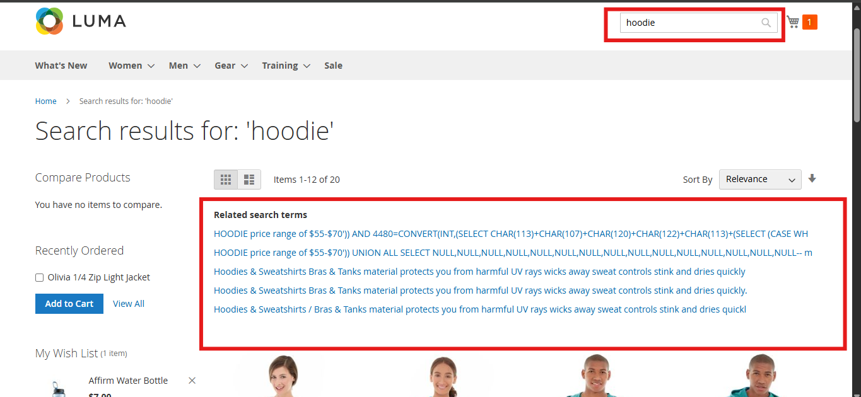

Note : if those vulnerabilities appear actually in the search results , so this issue is high.

**Website:** <https://magento.softwaretestingboard.com/checkout/cart/> and

<https://magento.softwaretestingboard.com/selene-yoga-hoodie.html> (the Product Name is and Example)

**Tested Area:** Cart Pop-up and Cart Page  
**Test Type:** Manual test on the product  
**Tester:** Aya Mohamed  
**Date:** April 7, 2025

**Steps to Reproduce**

1. Write in the search box like Hoodie
2. Click on the search button
3. Go to the product page and choose the size and color
4. Add the product to the cart
5. Check the Product Color in the cart pop-up and cart page comparing with the color chosen.

**Actual Result**

The color of the product in the cart pop-up and cart page not the color that was chosen.

**Expected Result**

The color in the cart pop-up and cart page should be the color that was chosen

**Severity:** Medium /Low

**Priority:** High

**Attached Images :**

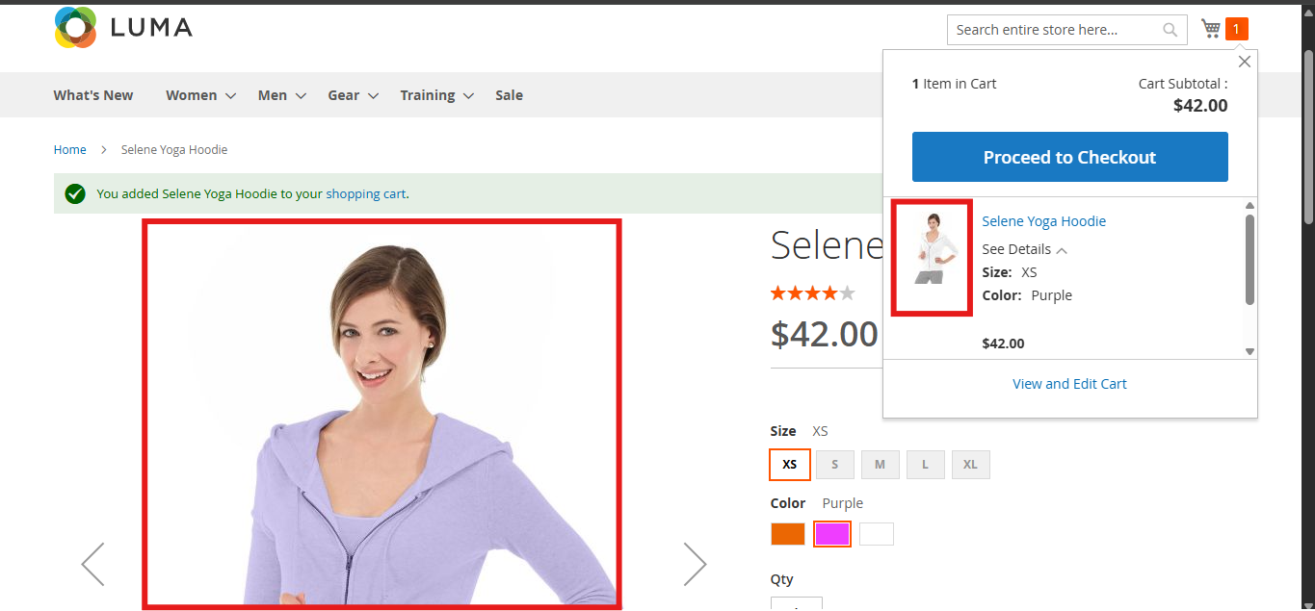

* **Basic Security Testing Report**

**Website:** <https://magento.softwaretestingboard.com>  
**Tested Area:** Search Bar  
**Test Type:** Manual Input Validation & SQL Injection Simulation  
**Tester:** Aya Mohamed  
**Date:** April 7, 2025

| **Field** | **Value** |
| --- | --- |
| **Vulnerability** | Potential SQL Injection & Information Disclosure |
| **Input Used** | admin' UNION SELECT NULL, username, password FROM users -- “in the Search Field” |
| **Observed Result** | One product was shown (Juliana Short-Sleeve Tee), and below that, multiple SQL queries were displayed in the suggestion box. These included:  SELECT * FROM users WHERE username = 'admin' AND password = 'password';  SELECT * FROM Users WHERE Username='1' OR '1' = '1' AND Password='1' OR '1' = '1' |
| **Expected Result** | The website should not return any internal SQL query or suggestion. It should display a safe “No results found” message. |
| **Severity** | **High** |
| **Risk** | The site reveals internal SQL logic, which may help attackers understand how authentication works. This can lead to real attacks on the database. |
| **Recommendation** | - Sanitize and validate all user inputs  - Do not return internal SQL queries in the UI  - Use prepared statements to prevent SQL injection attacks |

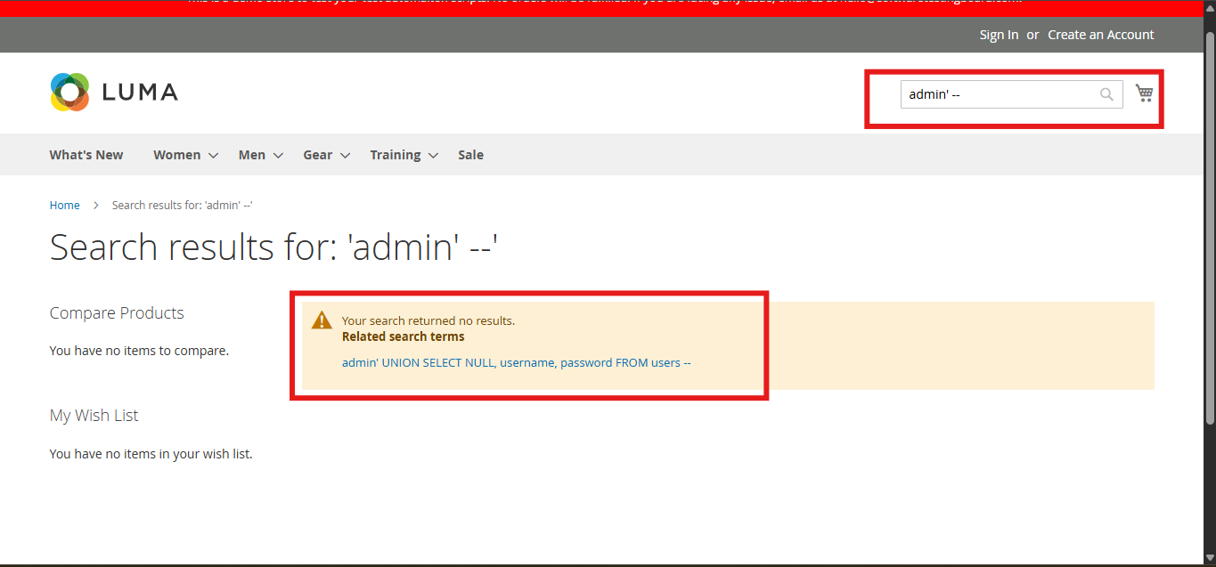

First try 🡪 admin’- -

Second try 🡪 with the suggestion one in the search result

May be an important vulnerability.